Name_______________________________
Position vs Time Graphs and Motion Maps
Scenario:
A student walks 10 meters north in 5 seconds, stands at her locker for 15 seconds, then walks 20 meters south to her classroom in 5 seconds.*
*This is a great opportunity to bring this scenario to life in the hallway or in the classroom (you could substitute locker for bookshelf, desk, or lab table).
Directions:
- Read the scenario with a small group or partner. Discuss the position, direction, and motion of the object and post your observations to Padlet.

- Create a position vs. time graph to describe the position, direction, and motion of the object.
25
10
5
Position (meters)
-10
0
5
-5
10
0
20
Position vs. Time
15
Time (seconds)

- Create a motion map to describe the position, direction, and motion of the object.

0m
15m

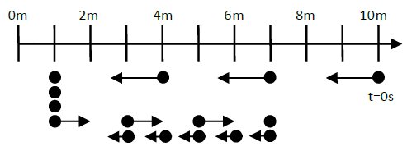
- Create a position time graph based on the following motion map.

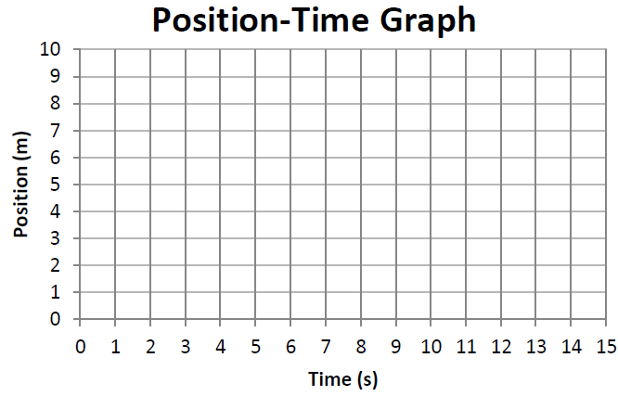

- Use the position-time graph to construct a motion map.
